Alan Truong

**Individual Report**

The part of the project that I worked on was the keyboard function in the group project. I made it so the user are able to press one of the three switch on the first row and it will either play an E, C, or D notes. The user are able to hold onto the switch and the note will continuous play by continuously sending out a square wave. So the hold note function was created in order for the user to hold onto the button. All the calculation was done together as a team for what frequency was used for each note and that was documented into our group report. I used Timer 1 for the note that was less than 16 bit.

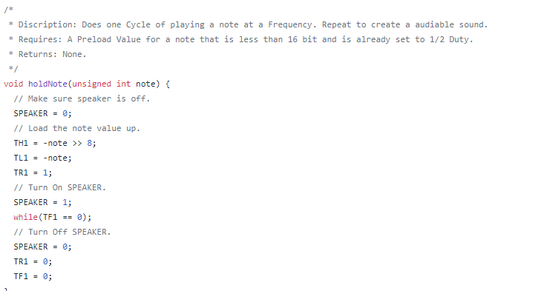

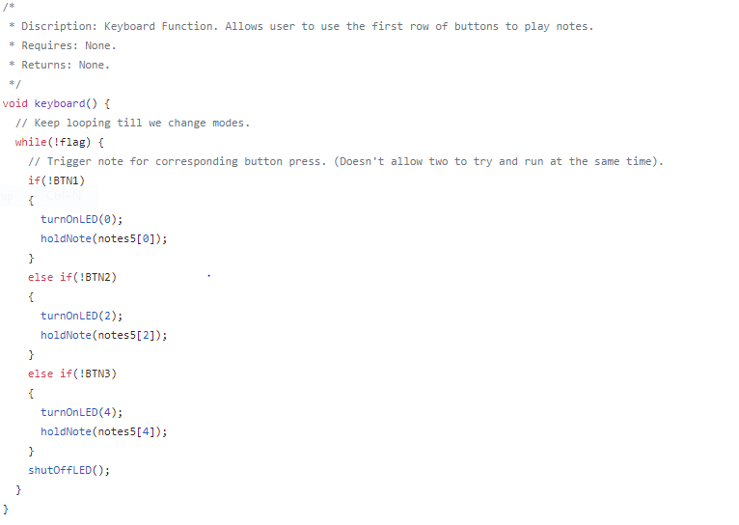

For my individual project I made it so whenever a certain type of note is being play then a certain LED will be turn on. So I made a turn on led and a shut off led function. Then I had to add it to whenever a note is being play it will take in a Char that will tell the turn on function what notes is being play in order for it to turn on the led. I also put in the beginning of the turn on led function the shutoff function to make sure all the LED is off before the next on is turn on. For the shut off led function I just set every single LED ports to 0 making sure they will be all off. I put the Turn on Led and Shut off led into the keyboard function which, the display note function and the keyboard 2 function. Then I put the shutoff led after every function called and the switch case after the song is finish playing so after the note is play the led will be shut off. In the turnOnLED function, case 0 and 1 are for C notes, but there we use C and C Sharp note, but because we don’t have enough LED on the board I combine sharp and flat notes for 1 LED. Case 2 and 3 was used for D notes, Case 4 was for the E note, Case 5 and 6 for F notes, Case 7 and 8 was for the G notes, 9 and 10 was for A notes and lastly Case 11 of the function was for B note.

